Forum followup - MDL-73415

- When no discussion is there show a notification on the view page:
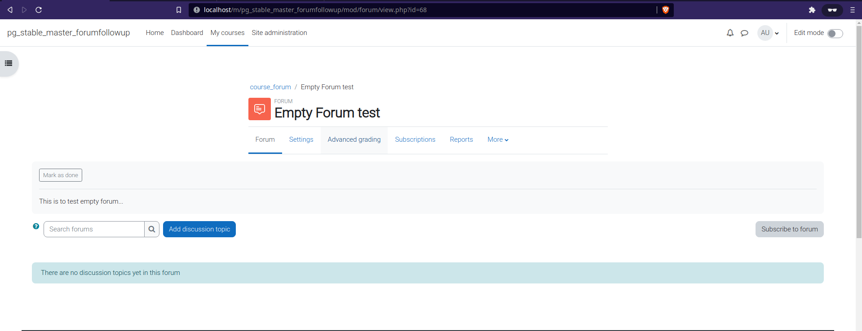
- Add headings for Subscribers tab in
A. View Subscribers
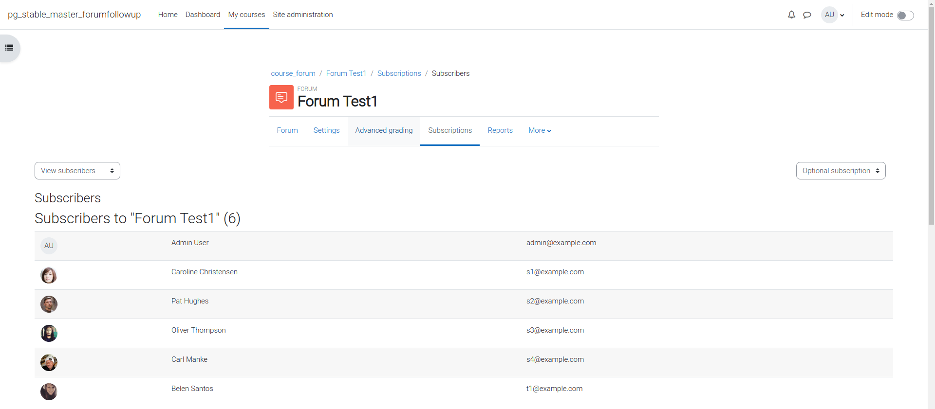
B. Manage Subscribers
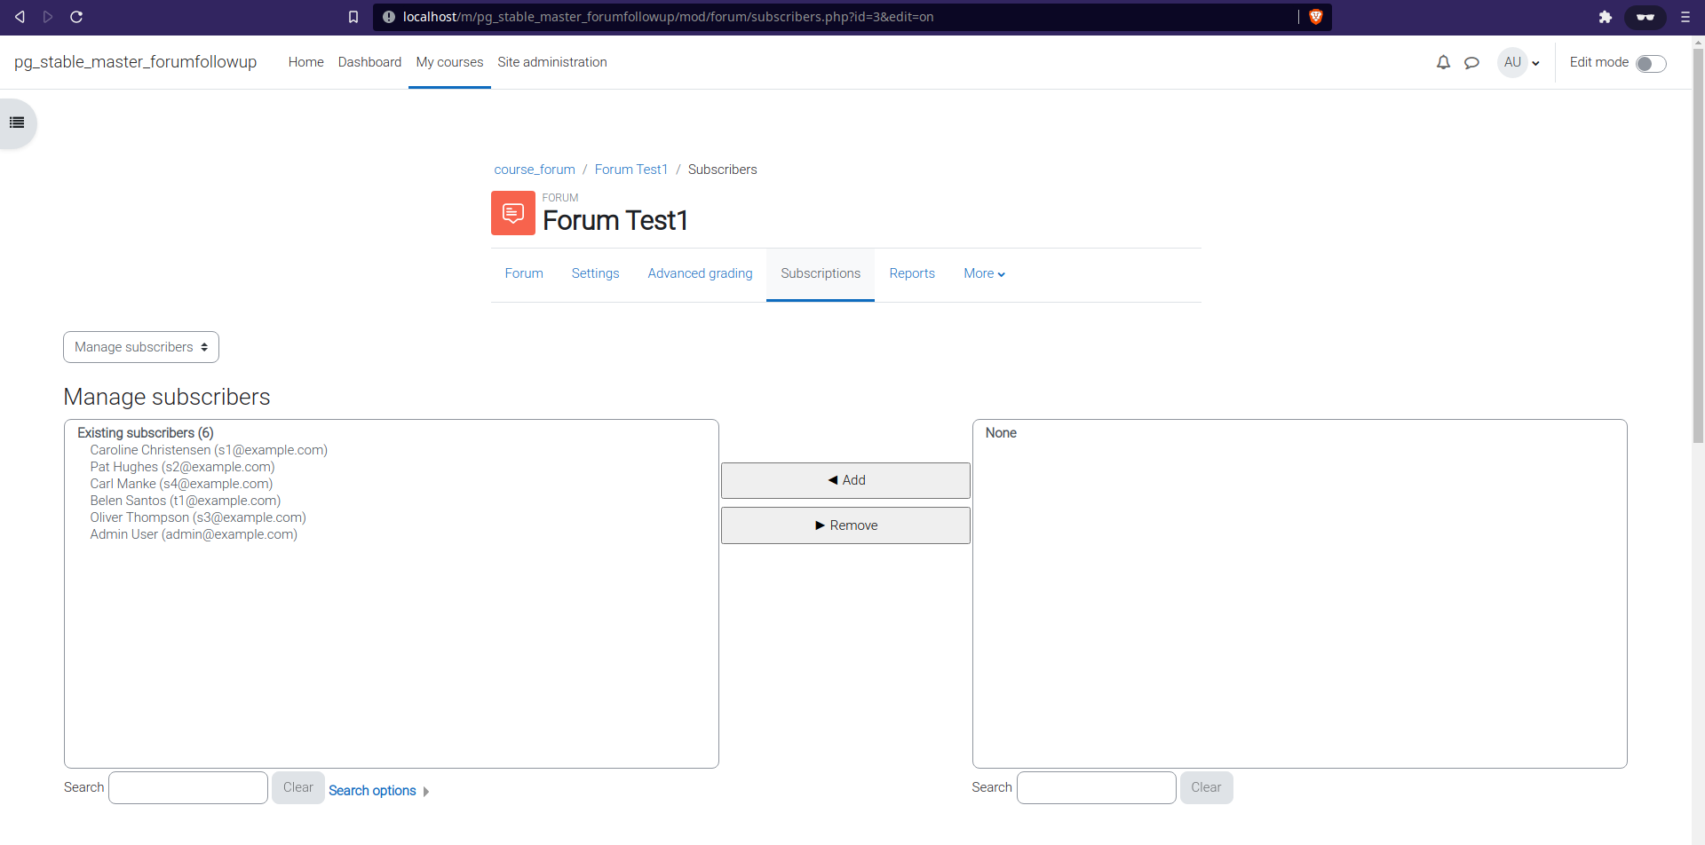
- Display notification when subscribers are there for the forum in the View Subscribers page:
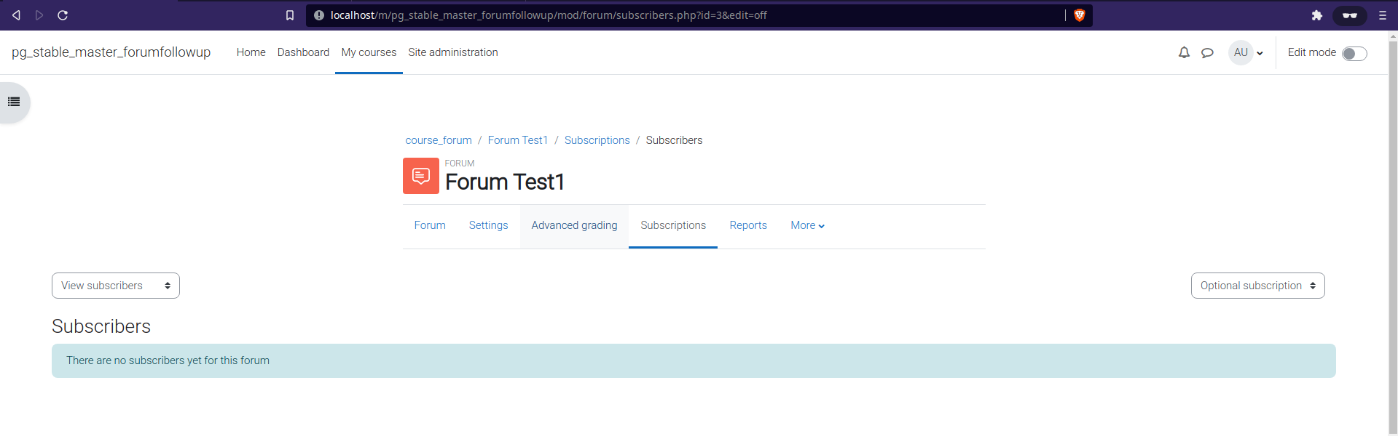
- When the forced subscription is enabled, then just removed the Manage subscription and View subscribers selection from the page:
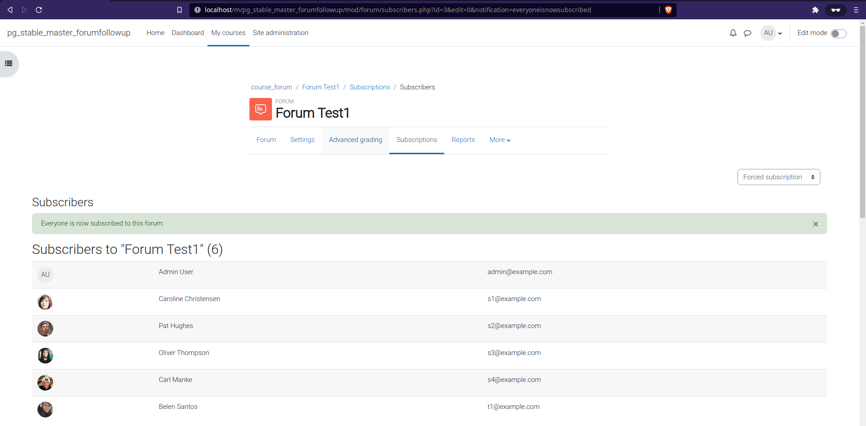
- Removed the subscription mode selector from the Manage Subscribers page:
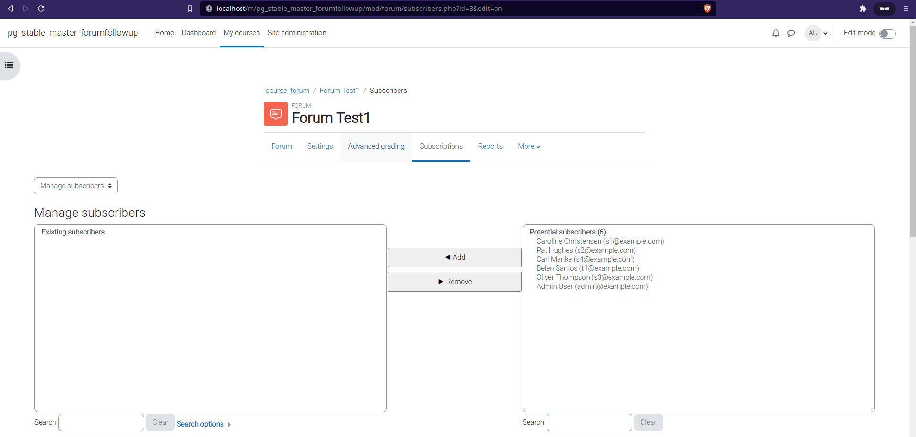
- Removed activity description from Add new discussion topic - Advanced page:
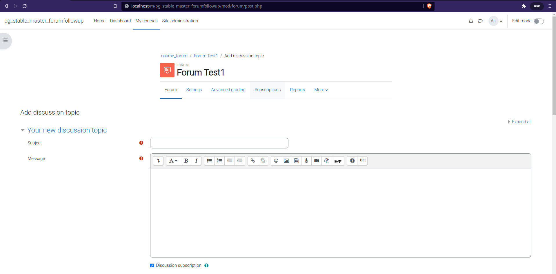
- Add heading to the Add new discussion topic - Advanced page:
See above image heading is there.
- Update bread crumbs to the add discussion topic.
See the above image the bread crumbs are added.
- When in given discussion topic, the settings dropdown menu should be changed to a dropdown button (right aligned) and should be vertically aligned with the rest of the selector elements (Display replies .. , Move discussion to...)
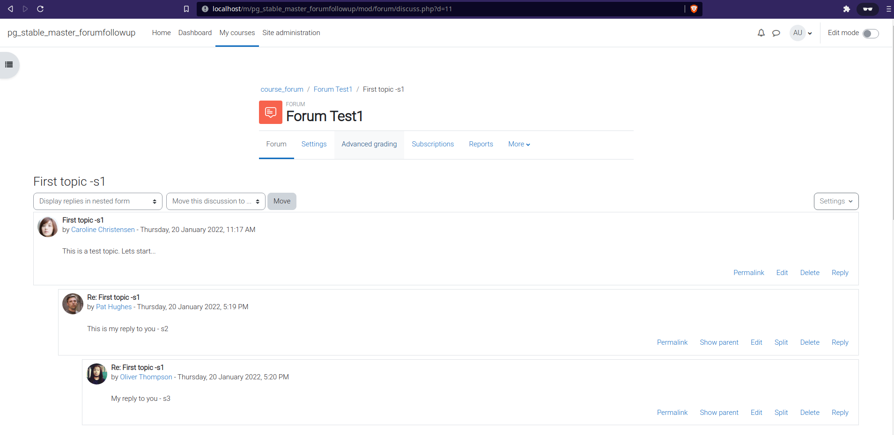
- Add heading to Edit discussion topic page:
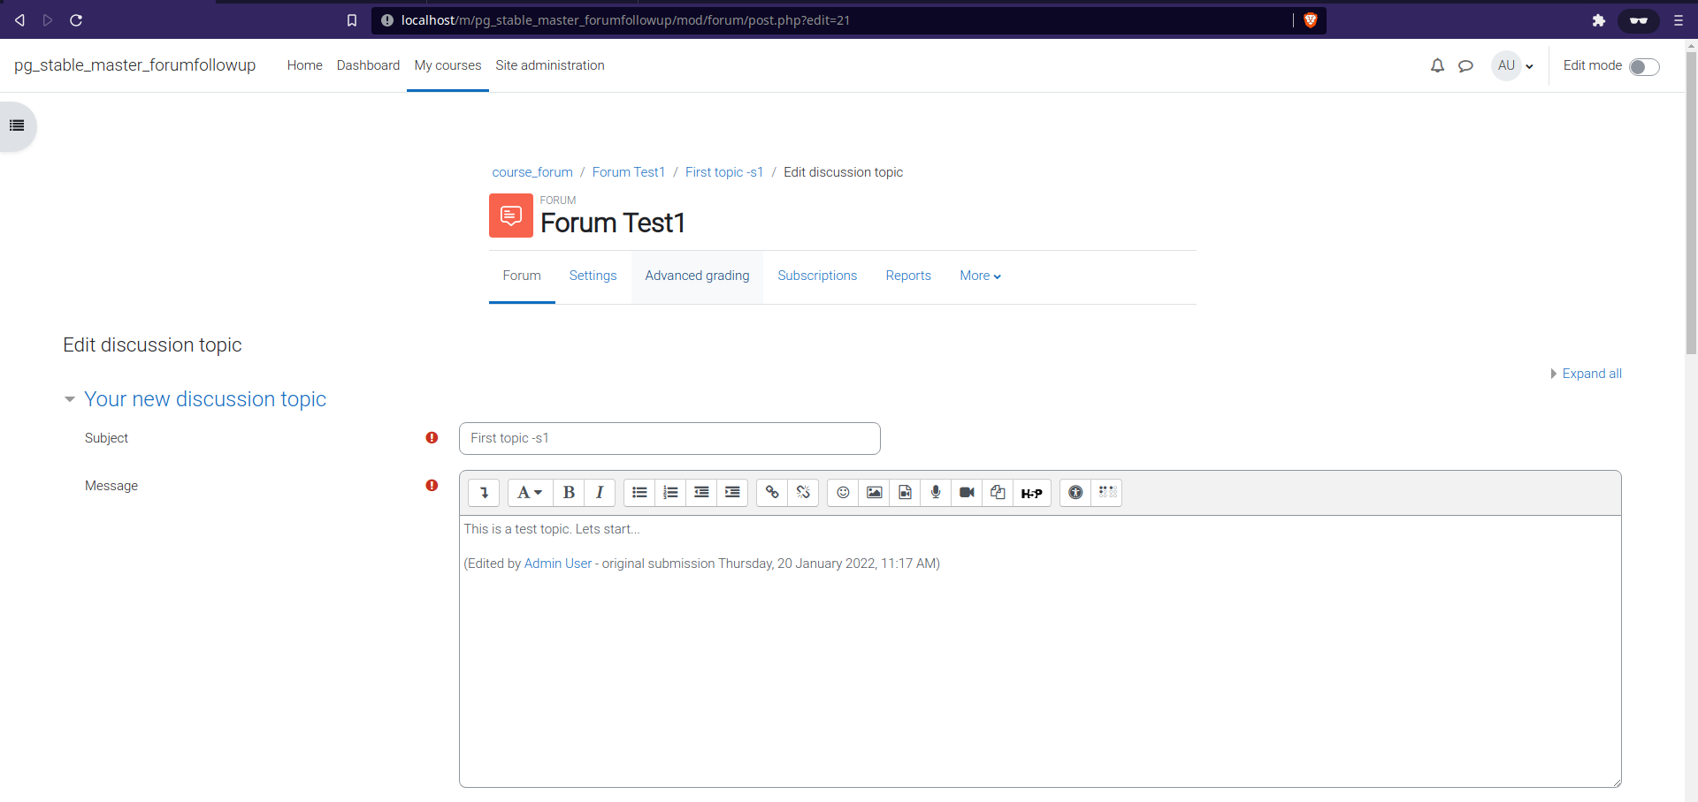
- Removee activity description in the Edit discussion topic page.
Check the above screenshot.
- Update the breadcrumbs in the Edit discussion topic page and add "Edit discussion topic" to the breadcrumb trail. Check the above screenshot.
- In the delete forum discussion page, highlight the 'Forum' item in the secondary navigation menu
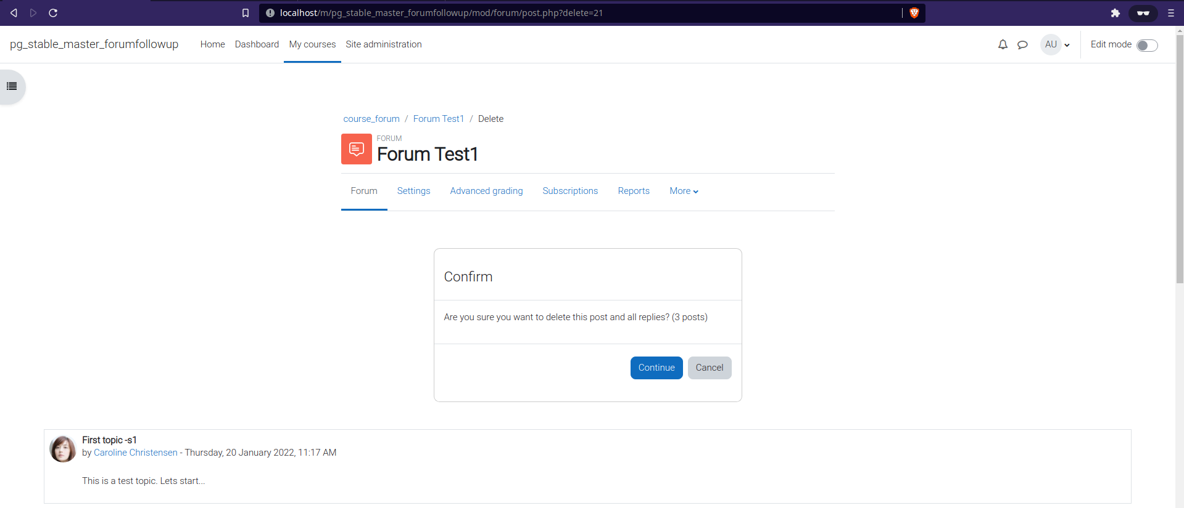
- In the delete forum discussion page, remove the activity description and activity completion section. Check the above screenshot.
- Update the breadcrumbs in the Add reply (advanced) page and add "Add reply" to the breadcrumb trail
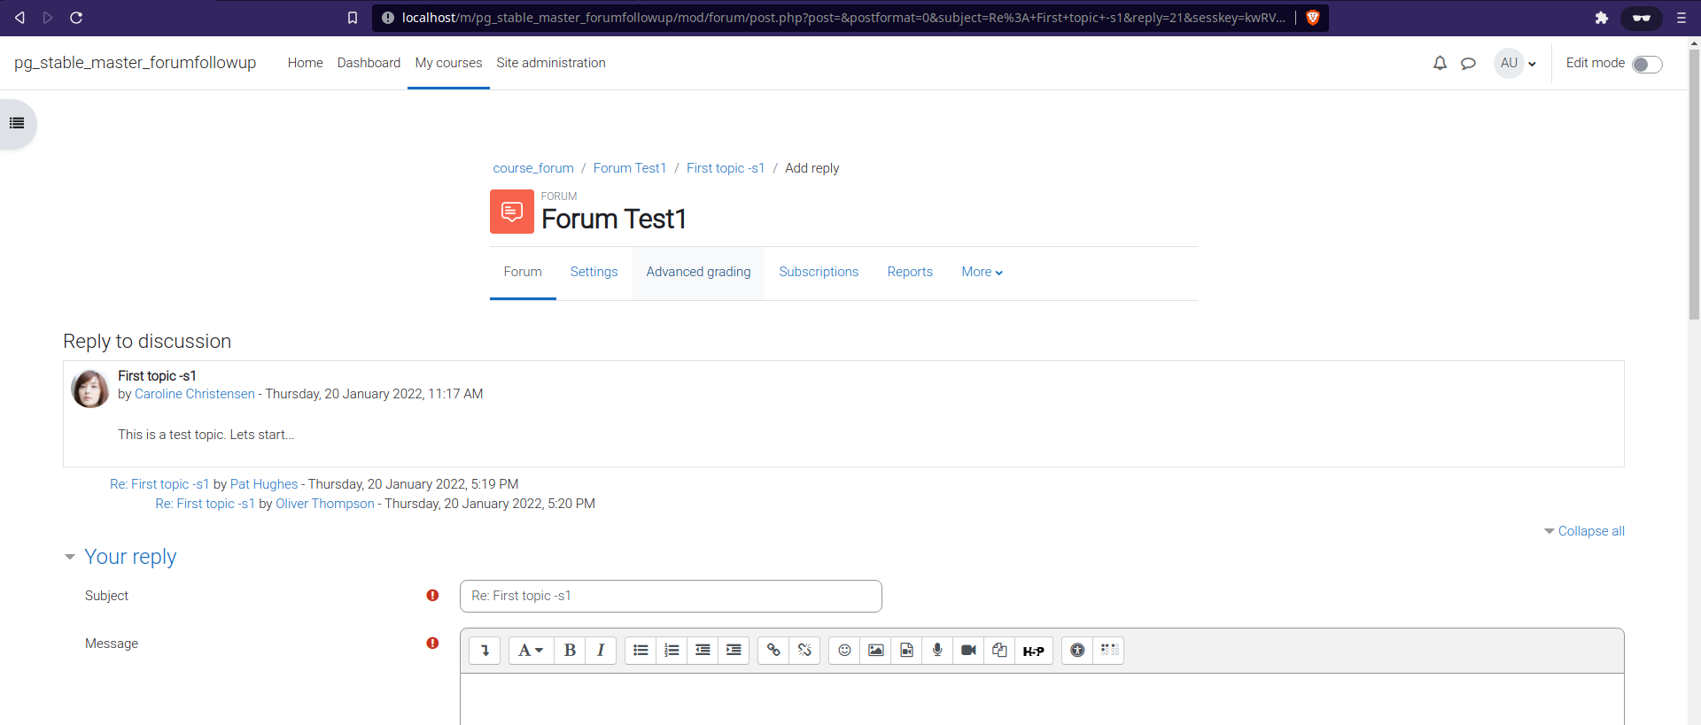
- In the split discussion page (has to be reply in a discussion topic), highlight the "Forum" item in the secondary navigation menu.
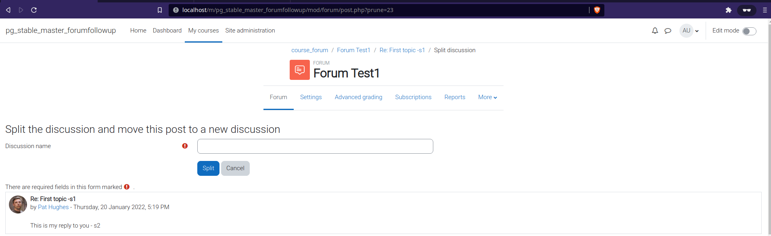
- In the split discussion page, remove the activity description and the completion section
Check the above screenshot.
- Update the breadcrumbs in the Split discussion page and add a link to the parent discussion to the breadcrumb trail
Check the above screenshot.
- Move the heading below the forum selector element in the Reports page and update the heading to "Forum summary report"
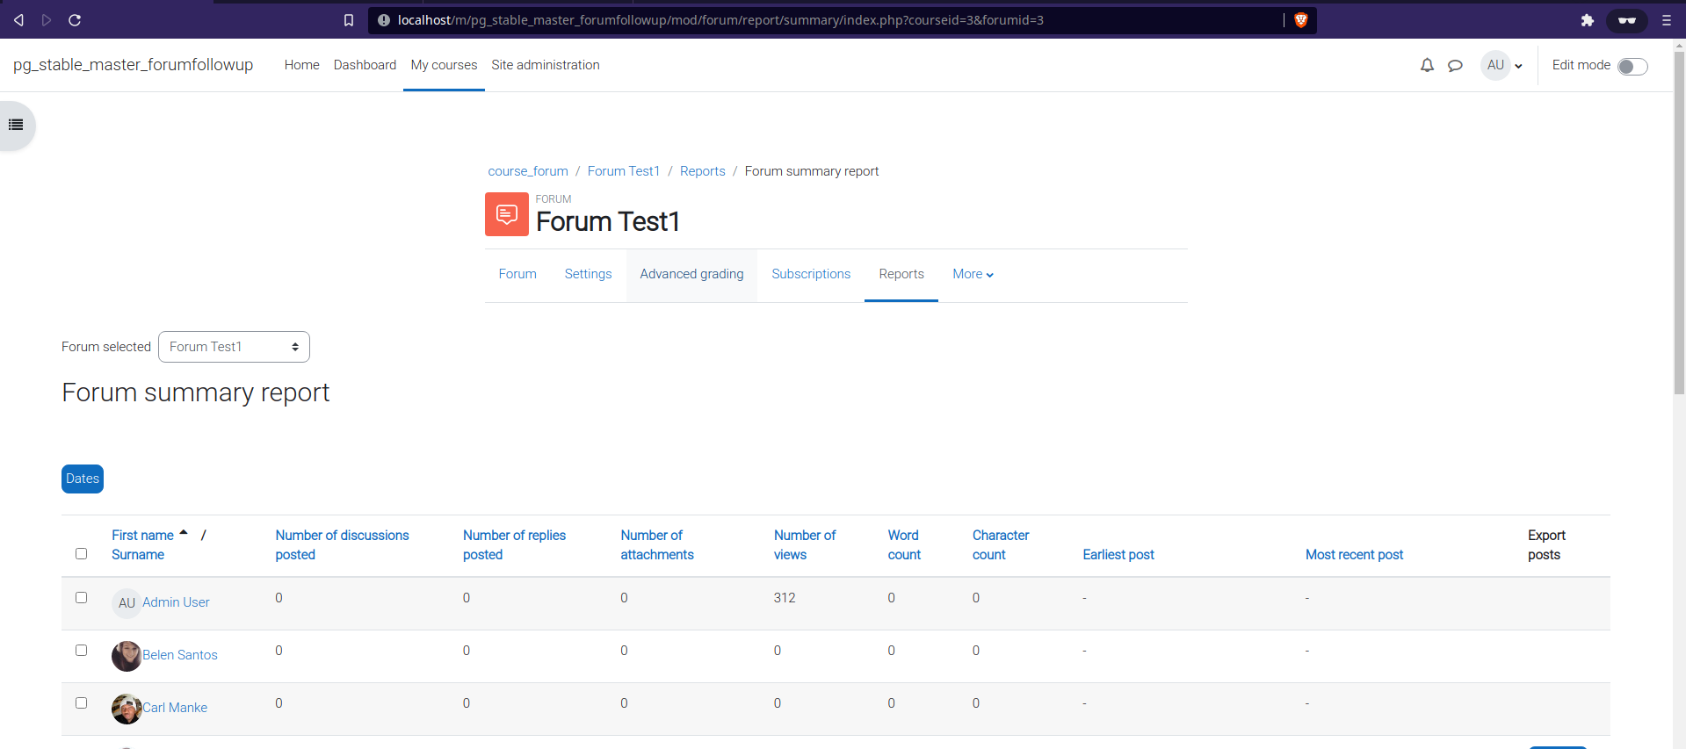
- If there is no results in the reports page, display an info notification instead of the h4 heading.
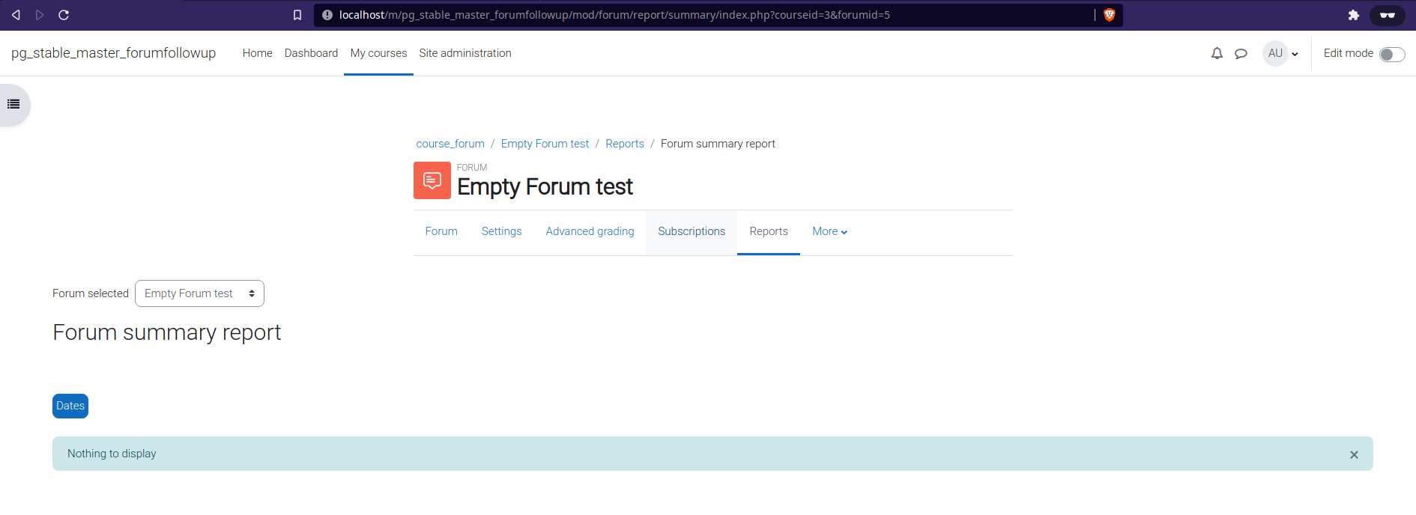
- Found function forum_update_subscriptions_button stale, as it's not used anymore after the recent changes made in MDL-71915. Done moved to deprecatedlib.php
- The forum subscription when changed by the user, it redirects back to the forum tab. Instead, it should be there on the subscription page. Done.
- Remove the following code as it is no longer required
https://github.com/moodle/moodle/blob/master/mod/forum/view.php#L110-L113
Done

